Office 365 - Error code 135011 when opening Outlook or OneDrive
Official URL: https://services.smsu.edu/TDClient/180/Portal/KB/Article/8137/Office-365-Error-code-135011-when-opening-Outlook-or-OneDrive
Category: Knowledge Base > Information Technology Services > Internal > Office 365 - Error code 135011 when opening Outlook or OneDrive
Tags: outlook, onedrive, MFA
_____________________________________________________
Issue
When a user attempts to open Outlook or OneDrive, they receive an error similar to the screenshot below.
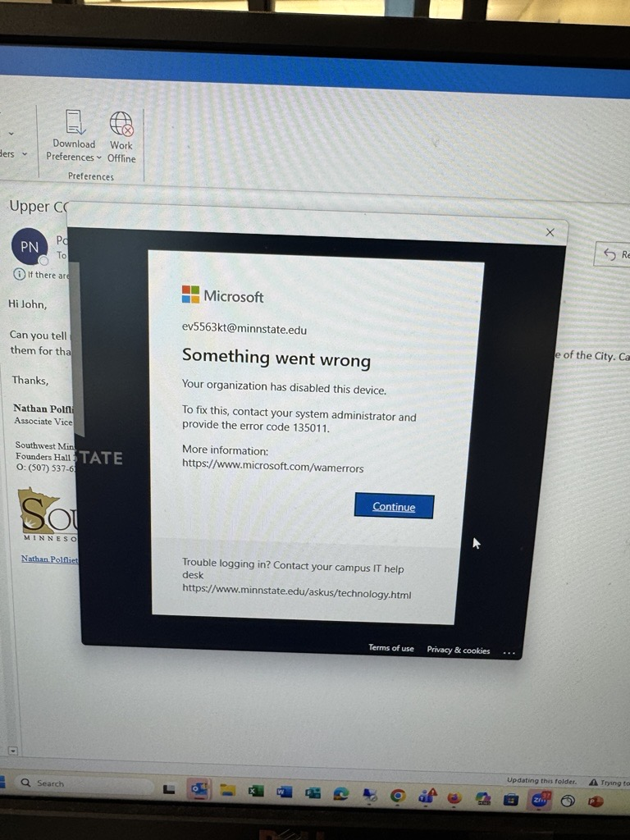
Figure 1: Uploaded Image
Description
This error indicates that the device has been removed from the user's O365 account as an approved device.
Resolution
Open a normal command prompt (not as admin) and type dsregcmd /forcerecovery and press enter. This will begin the process of registering the device with O365. Follow any initial prompts then open Outlook you will need to sign in and register the device.
Accessibility Review & Update Log:
- [ ] Content accuracy verified
- [ ] Color contrast checked
- [x] Image alt-text verified (screenshots auto-captioned)
- [x] Document structure and headings formatted (perfect bold, list bulletpoints and sequences preserved)

